ASSIGNMENT
24MCAT103-Digital Fundamentals and Computer Architecture
24MCAT107-Advanced Software Engineering

Submitted by: ARUN BIJU THOMAS
Roll no:19
RMCA S1
Simulating Cache Memory Mapping and Replacement Algorithms using Git Collaboration

Scenario: You are part of a development team tasked with creating a Cache Simulation Tool that models the behaviour of different cache mapping functions (Direct, Associative, Set Associative) and cache replacement algorithms (FIFO, LRU, LFU).

PROGRAM
def show_frames(frames, frame_size):
display = frames[:]
while len(display) < frame_size:
display.append('-')
return display

def lru(pages, frame_size):
frames = []
recent = {}
time = 0
hits = 0
misses = 0
print("LRU Simulation ")
for p in pages:
time += 1
print(f"\nPage → {p}")

if p in frames:
hits += 1
recent[p] = time
print("HIT →", show_frames(frames, frame_size))
continue
misses += 1

if len(frames) < frame_size:
frames.append(p)
recent[p] = time
print("MISS →", show_frames(frames, frame_size))
continue

lru_page = min(recent, key=recent.get)
frames[frames.index(lru_page)] = p
del recent[lru_page]
recent[p] = time
print(f"MISS (replaced {lru_page}) →", show_frames(frames, frame_size))
print("\nTotal Hits:", hits)
print("Total Misses:", misses)
print("Hit Ratio:", hits / len(pages))

pages = list(map(int, input("Enter page reference string: ").split()))
frame_size = int(input("Enter number of frames: "))
lru(pages, frame_size)

OUTPUT
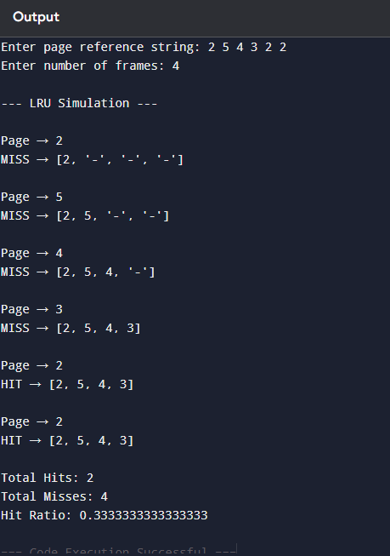

ALGORITHM
- Start
- Create an empty list mem = []
and set faults = 0.
(The leftmost element will be the least recently used,
and the rightmost is the most recent.)
- For each page p in the page reference string:
- If p is already in mem:
• Remove p from its position
• Append p again to the end (mark it as most recently used)
• Print HIT and the current mem
- Else (page not in memory):
• faults += 1
• If memory has free space:
– mem.append(p)
• Else (memory full):
– Remove mem[0] (the least recently used page)
– Append the new page p
• Print MISS and the current mem
- At the end, return faults.
- Stop

FLOW DIAGRAM EXPLANATION
This flowchart explains how the LRU page replacement program works.
First, the program starts by taking two inputs from the user: the page reference string and the number of frames available in memory.
After reading the inputs, the program sets up the initial values.
The memory (frames) is empty, and the hit count, fault count, and time counter are all set to zero.
The time counter is used to keep track of how recently each page was used.
The program then begins processing the pages one by one from the reference string.
For each page, the program checks whether the page is already present in memory.
- If the page is present, it is considered a hit, and the hit count is increased. The time value of that page is also updated because it was just used (this helps the LRU logic).
- If the page is not present, it is considered a miss, and the fault count is increased. Then the program checks whether the memory still has empty frames.
- If there is space, the new page is simply added to memory.
- If the memory is full, the LRU algorithm is applied.
  - The program finds the page that was used the longest time ago and removes it.
  - The new page replaces that old one.
After every operation, the current state of the memory frames is displayed.
This continues until all pages in the reference string have been processed.
Finally, the program calculates and displays the number of hits, faults, and the hit ratio.
The process then ends.

FLOW DIAGRAM
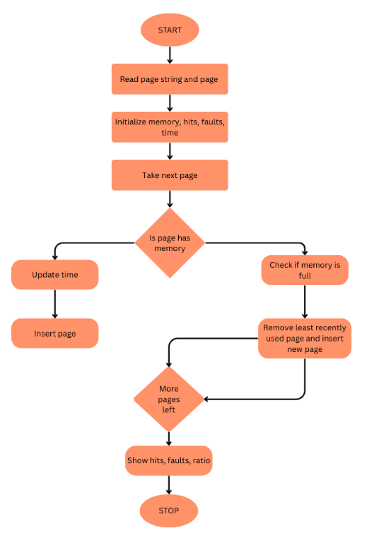

REPORT
This assignment focuses on understanding memory management by implementing a page replacement simulation using the LRU (Least Recently Used) algorithm. The program is written in Python and takes a page reference string and frame size as input. For every page request, the simulator checks whether the page is already available in memory. If it exists, it is recorded as a hit; otherwise, a page fault occurs.
When a fault happens and memory is full, the LRU algorithm is used to decide which page should be removed. LRU selects the page that has not been used for the longest time. The simulation then replaces this least recently used page with the new one. At each step, the updated frame contents, hit count, and fault count are displayed. A final summary shows total hits, faults, and hit ratio.
The assignment also helped practice software engineering concepts such as organizing code, writing algorithms, and designing a clear flowchart that explains the working process. Through this simulation, the concepts of caching, memory frames, and page replacement became easier to understand.

SCREENSHOTS OF GITLOG:

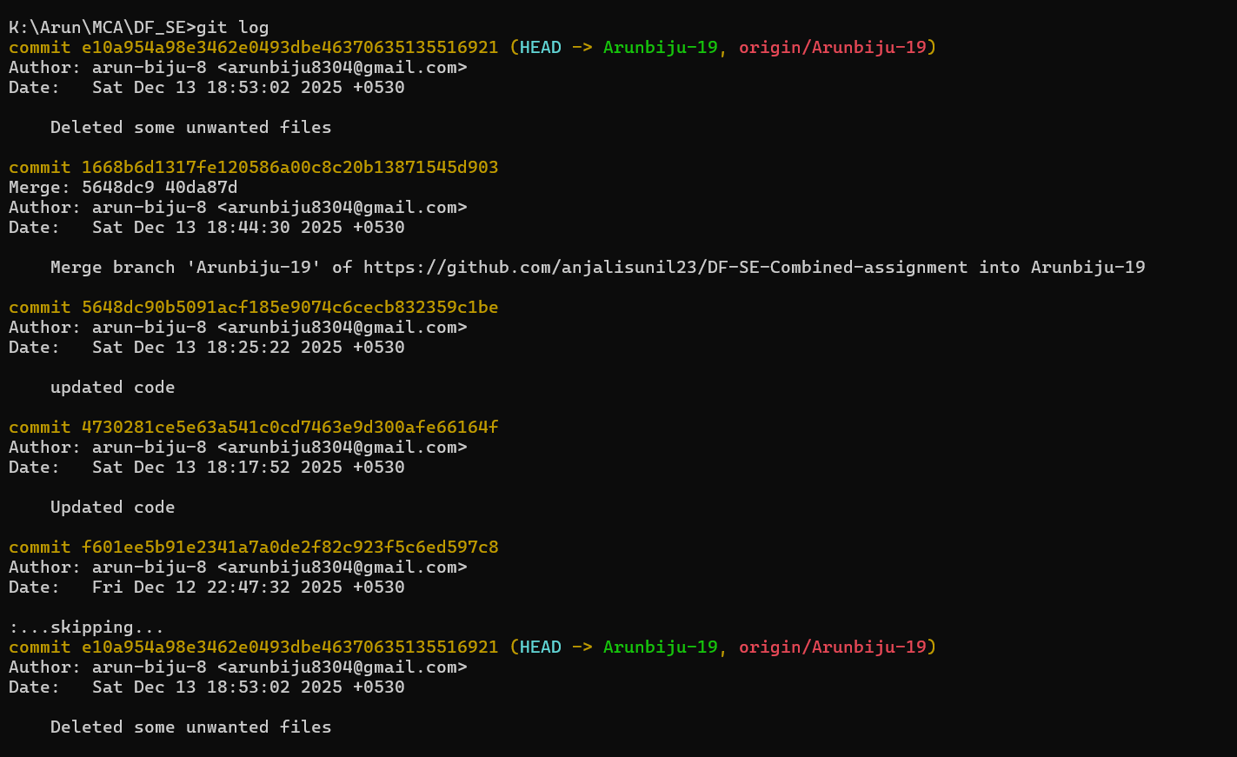

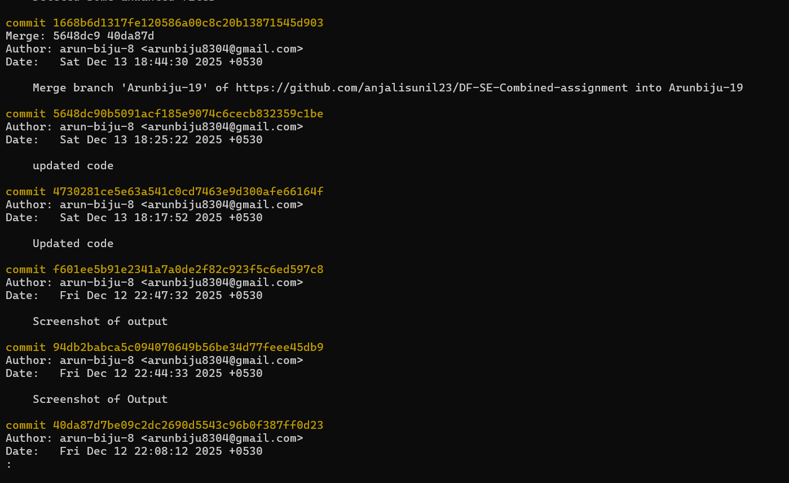

REFLECTION
Implementing the LRU page replacement algorithm helped me understand how operating systems manage memory in practical situations. Writing the logic in Python made the concept clearer, especially how hits, faults, and page replacements occur. Instead of only learning theory, coding the algorithm showed me how the system identifies the least recently used page and replaces it when frames are full. Creating the flowchart also helped me visualize each step—from checking if the page is present to selecting the victim page.
Working with Git added another important learning experience. Creating branches, pushing updates, and merging changes taught me how collaboration works in real projects. I also faced issues like merge conflicts, which helped me understand the importance of proper commits and organized version control. These challenges improved my confidence in using Git and GitHub for teamwork.
Overall, this assignment combined OS concepts with programming and software engineering practices. It strengthened my understanding of memory management and improved my ability to structure code, use Git effectively, and document my work clearly.

Workflow Diagram
